*Sent to all Members*  
  
May 12, 2024  
  
Dear {%FName%},

This is a Rotary Foundation Minute provided by District 6220 Governor-Elect and Paul Harris Society Coordinator Roger Utnehmer. Please read at club meetings and post on social media and in club newsletters.

===========================================================

“This is a Rotary Foundation Minute.

One of Rotary International’s Seven Areas of Focus is to foster peace and resolve conflict. The Foundation supports peace-building and conflict resolution throughout the world.

Today we have an opportunity to build goodwill and better friendship, to promote peace and resolve conflict with our American Indian neighbors.

Most Rotary Clubs meet on land formerly occupied by Native Americans. They are a people from whom much has been stolen: their culture, land, children, language, images and more.

Every Rotary Club in District 6220 can reach out to our Indigenous neighbors with a simple act of kindness and respect.

Rotary conferences throughout the world are starting meetings with a Land Acknowledgement Statement.

What follows is an appropriately-edited version of the statement used recently by Rotary International.

“Today we are meeting on lands formerly occupied by Indigenous peoples, many of whom were forced to leave generations ago.

Rotary International recognizes the historical and ongoing impact of colonization on Indigenous communities.

We pay respect for our First Nation elders, past, present and future….

…and we express our respect and gratitude for All First Nation people for preserving and protecting the lands on which Rotarians meet.”

Please consider starting your club meetings with this short acknowledgement.

It is one step, an initial gesture, that will build goodwill and better friendship, promote peace and resolve conflict.

Roger Utnehmer    
Rotary District 6220 PHS Coordinator   
District Governor 2024-25   
(C) 920 495 9677   
[utnehmer@gmail.com](mailto:utnehmer@gmail.com)

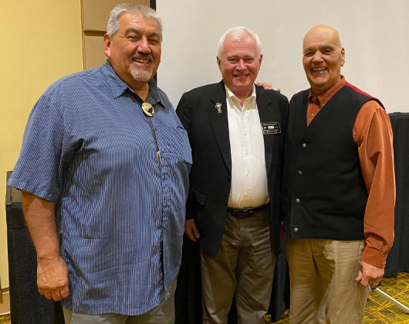

L to R: Dr. Artley Skenandore, Roger Utnehmer, Norbert Hill, Jr.

At 2024 Rotary TriCon Conference “Cultural Appreciation Initiative.”